Answer 1:- 17.72

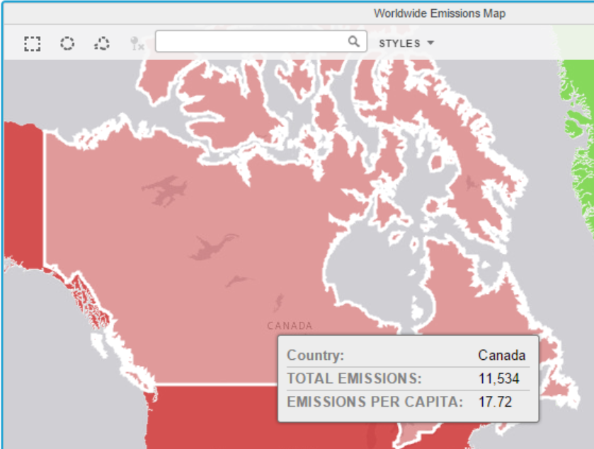

Answer 2:- Overall trend of emissions is increasing except in 2009 when it decreased

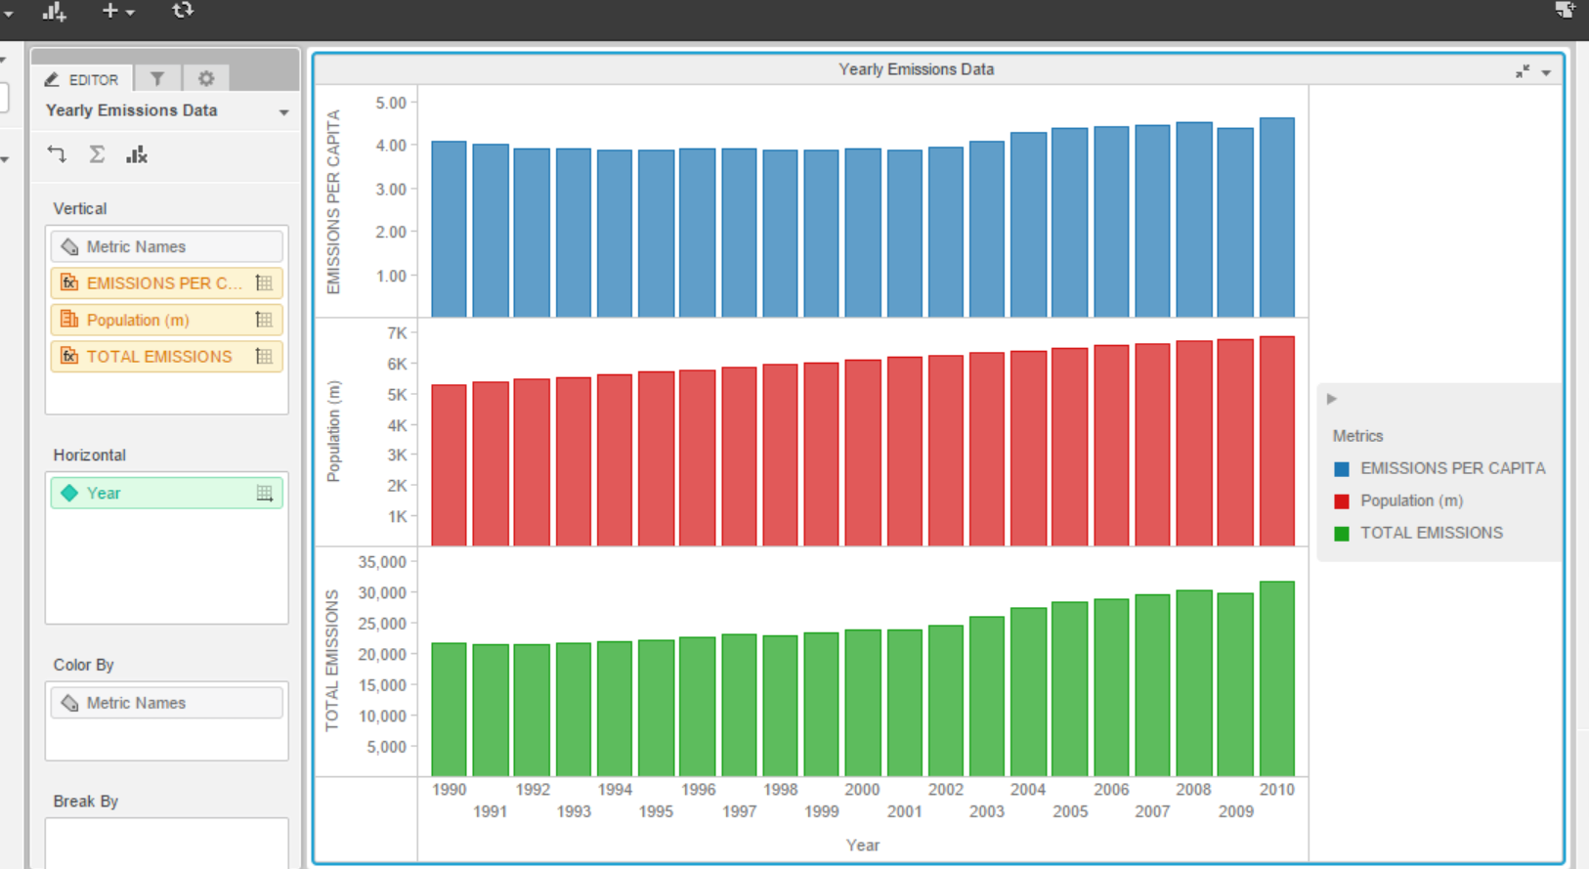

Answer 3:- Global emissions decreased in 2009 due to the global economic crash of 2009

